# Worksheet 1A Processor components

**Task 1**

1. Match the processor components with the correct descriptions:

|  |  |  |
| --- | --- | --- |
| Arithmetic-Logic Unit |  | A single memory location in which intermediate arithmetic and logic results are stored |
| System clock |  | Directs and coordinates the operation of the processor and controls the flow of data within the CPU |
| Program counter (PC) |  | Holds the current instruction being processed |
| Current Instruction Register (CIR) |  | A continuously cycling signal that is used as a timing pulse for all processor components |
| Accumulator |  | Holds memory address of next address to be processed |
| Control Unit |  | Used to carry out the instructions received by the processor and produce the processed output |

**Task 2**

1. An incomplete diagram of processor components is shown below including possible data stored in various registers. The accumulator contains the value #30. The address 23 contains the instruction ADD #20. Complete the diagram by labelling the name of each component.

*Tip: Think about the contents and connections of each part.*

|  |  |
| --- | --- |
| **Program Counter** | **Memory Address Register (MAR)** |
| **Memory Data Register (MDR)** | **Current instruction Register (CIR)** |
| **Accumulator (ACC)** |  |

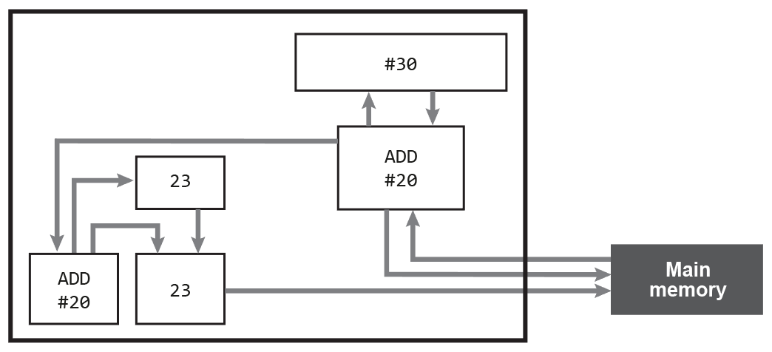

In the spaces below, justify your decisions:

* 1. Program counter contains memory address of next instruction
  2. Memory Address Register is passed the memory address of instruction to be executed
  3. Memory Data Register contains the instruction that has been fetched from memory
  4. Current instruction Register holds onto instruction copied from MDR
  5. Accumulator contains the value #30